**DB Lab 12**

**Name:** Hafsa Salman

**Roll no.** 22K-5161

**Task no. 01**

**Task no. 02**

**Task no. 03**

**Task no. 04**

**Task no. 05**

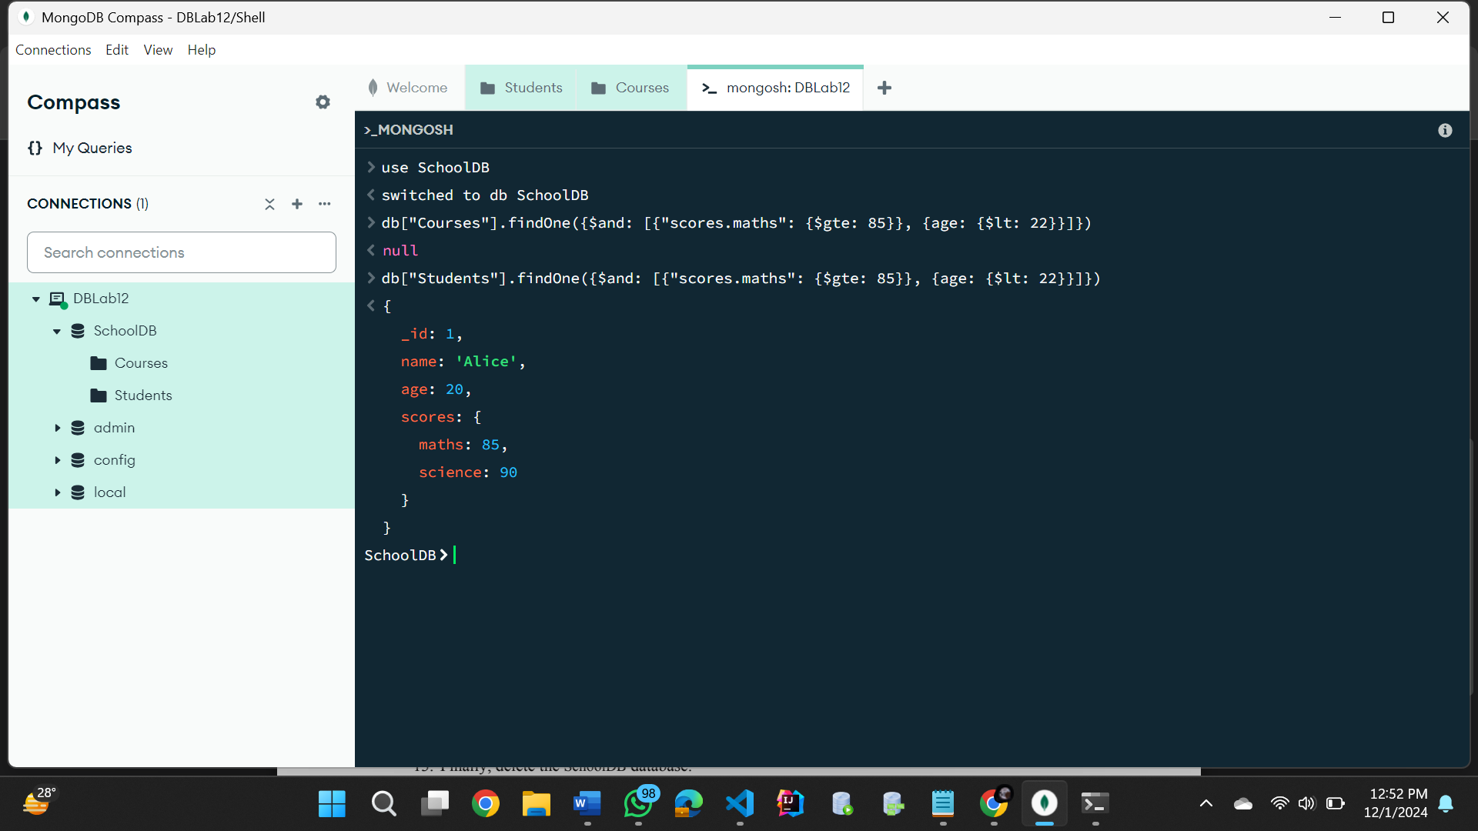

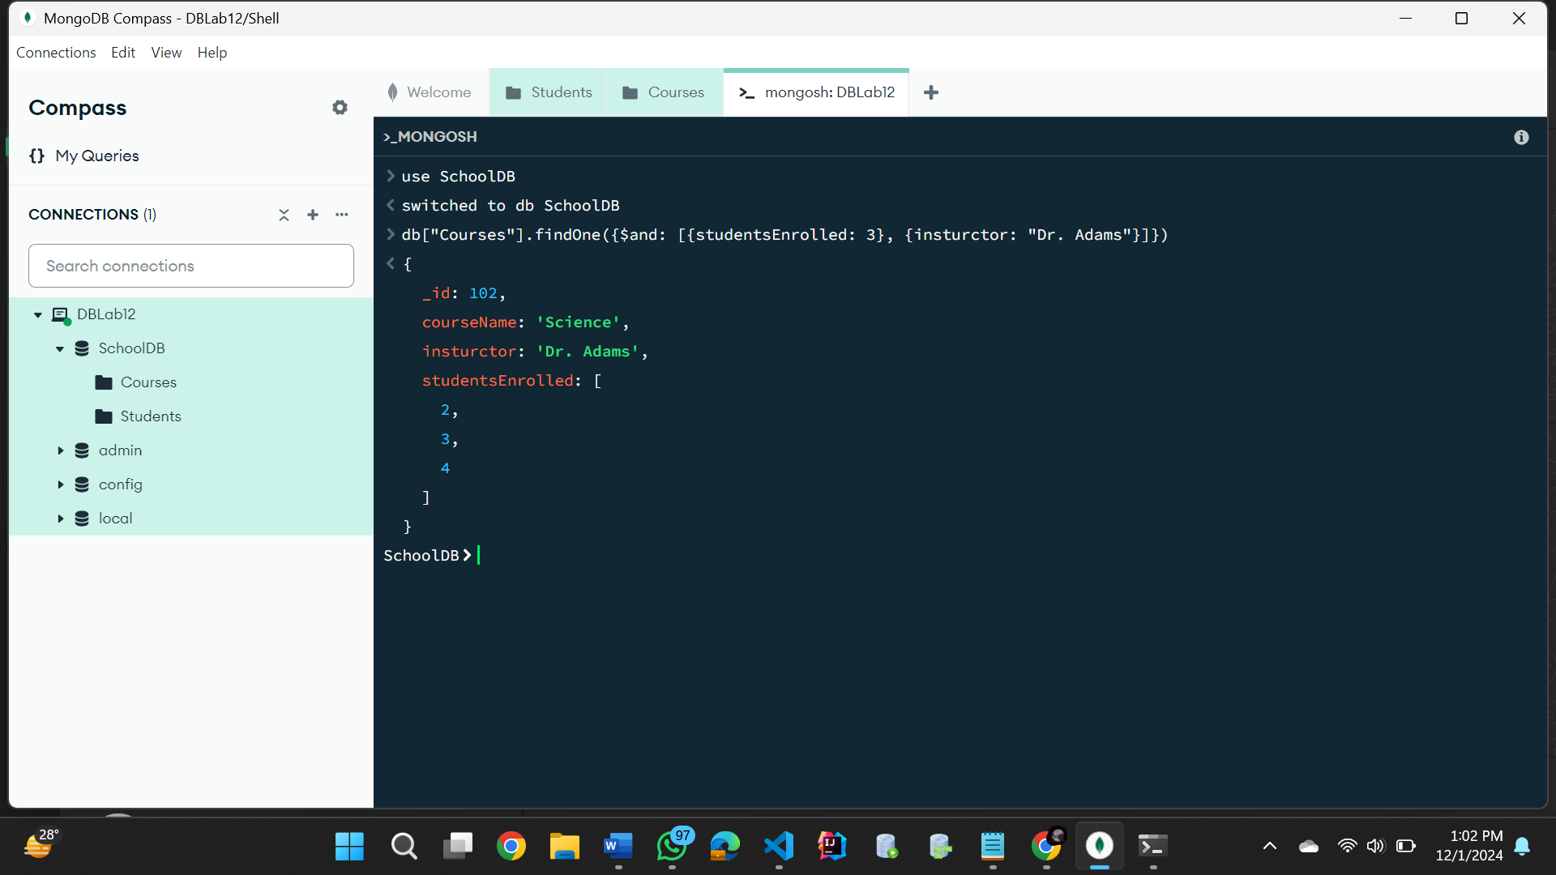

**Task no. 06**

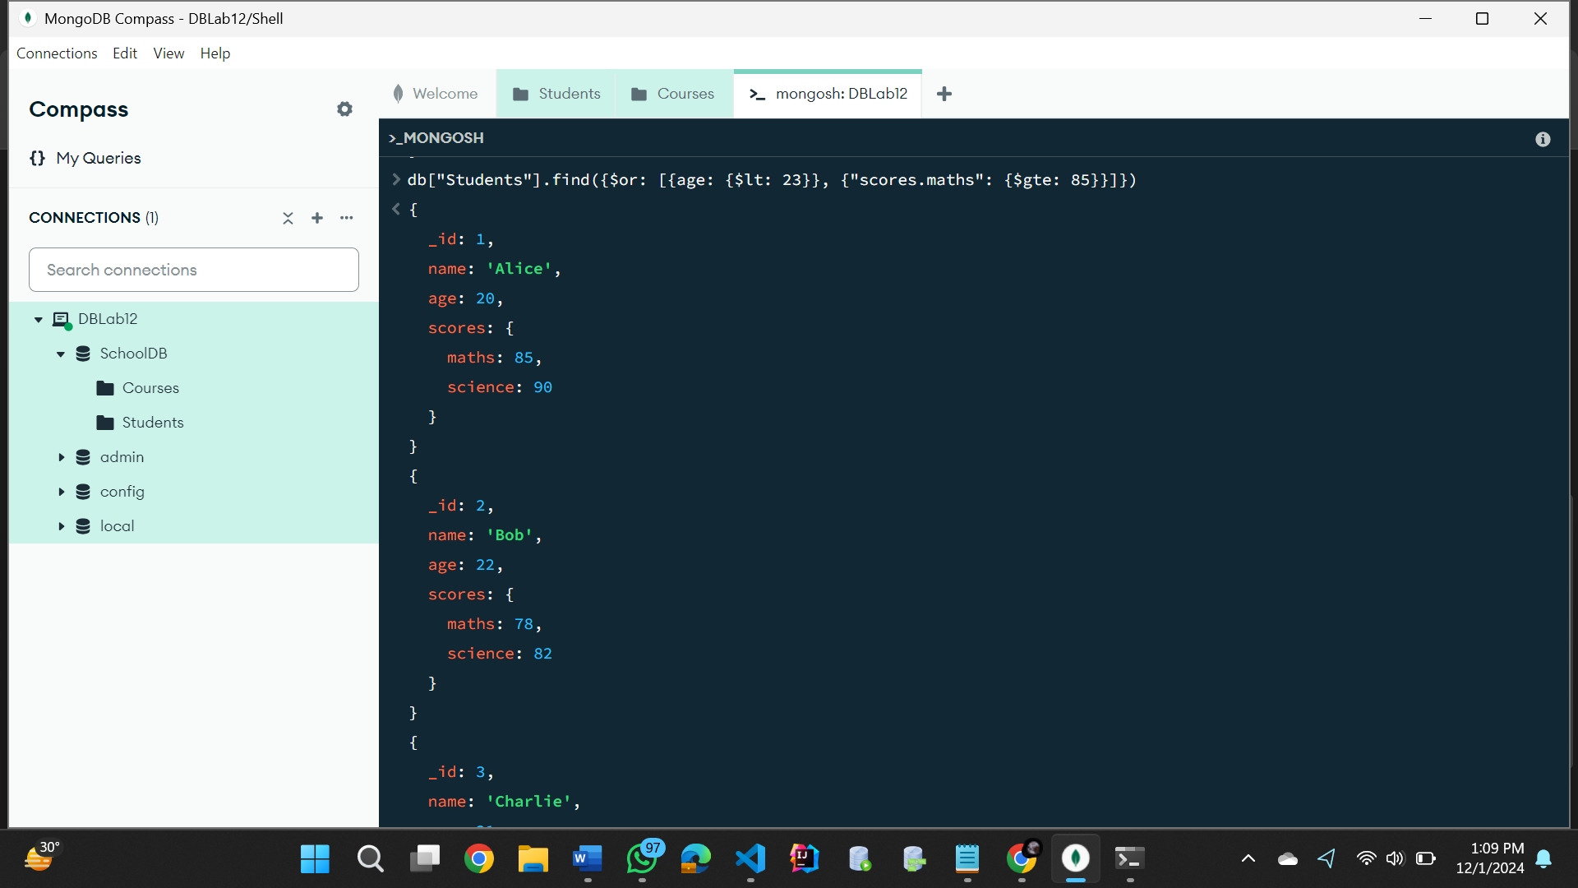

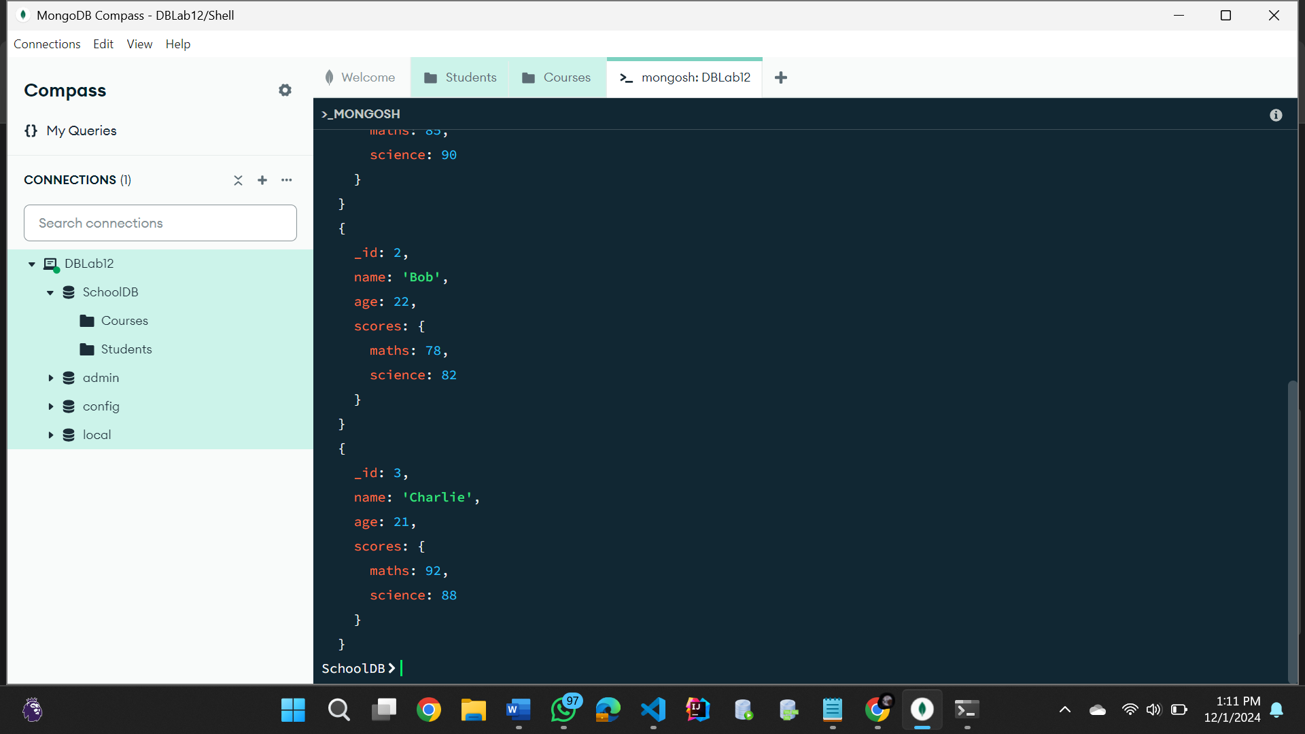

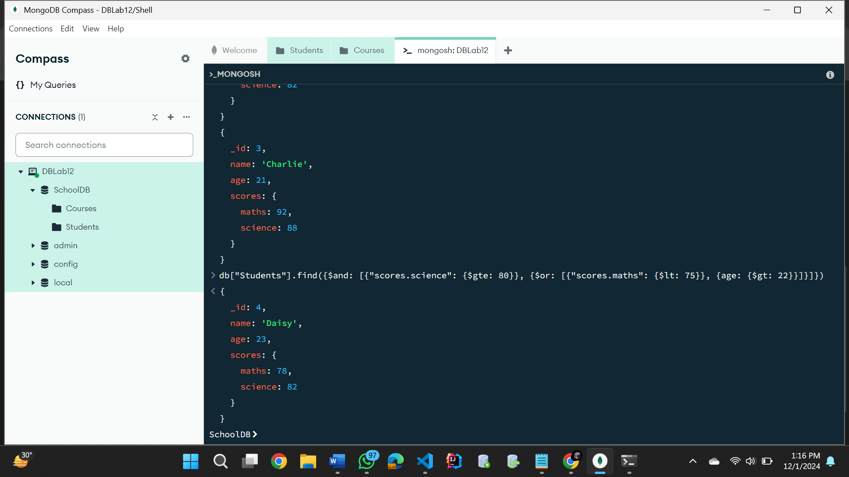

**Task no. 07**

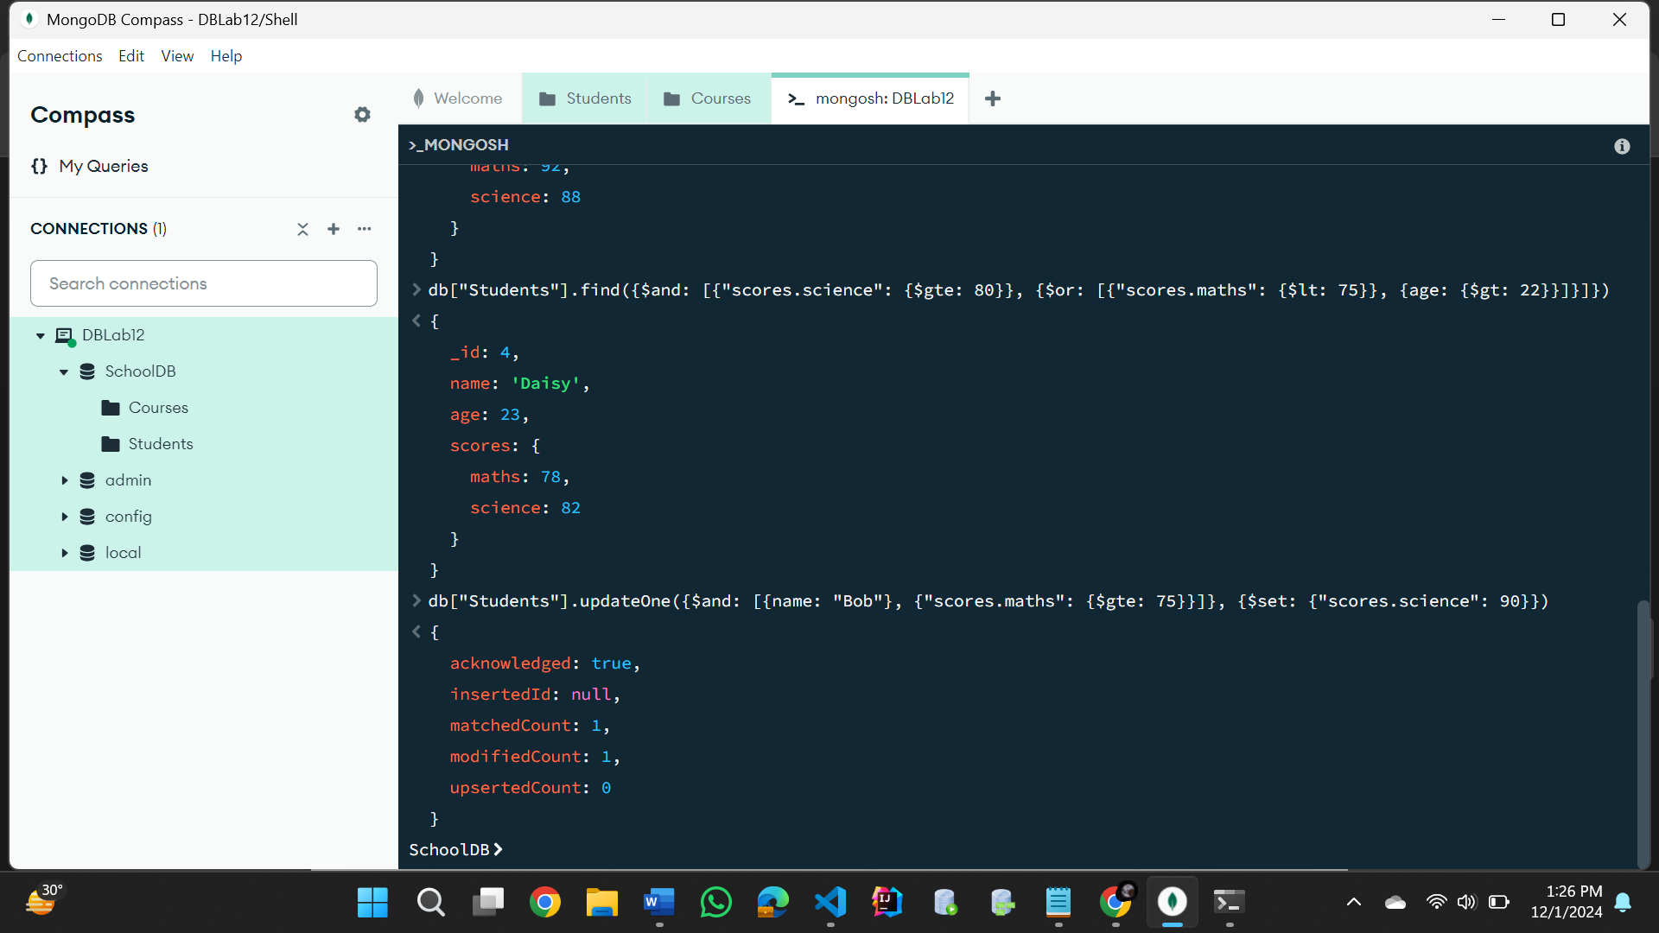

**Task no. 08**

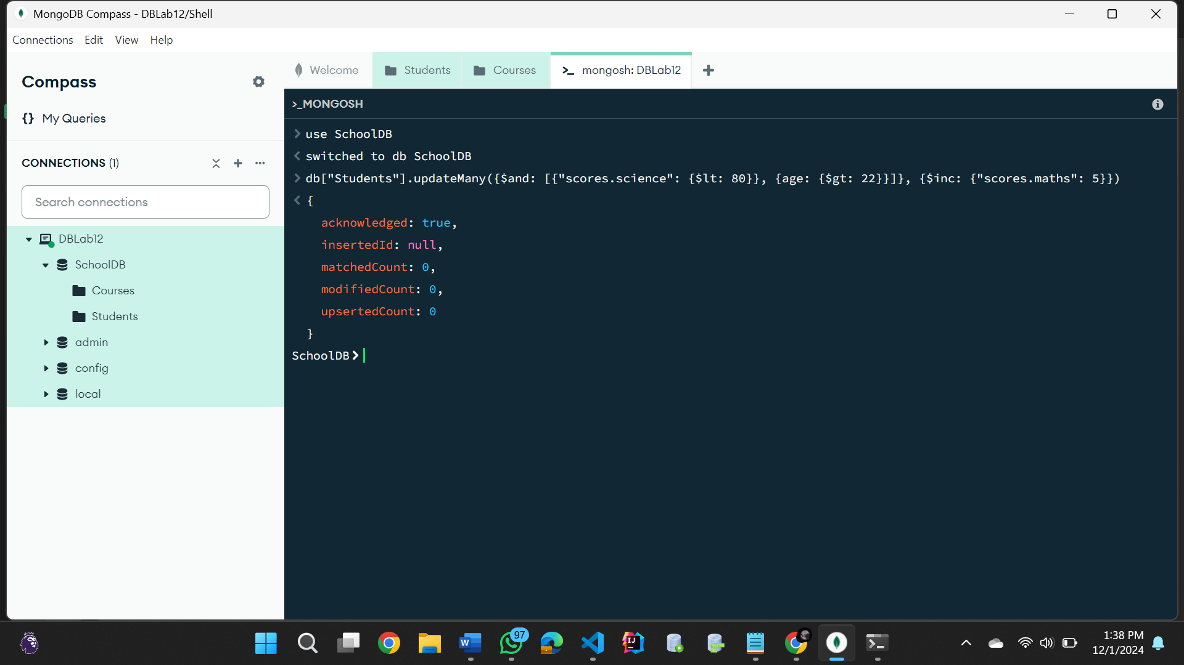

**Task no. 09**

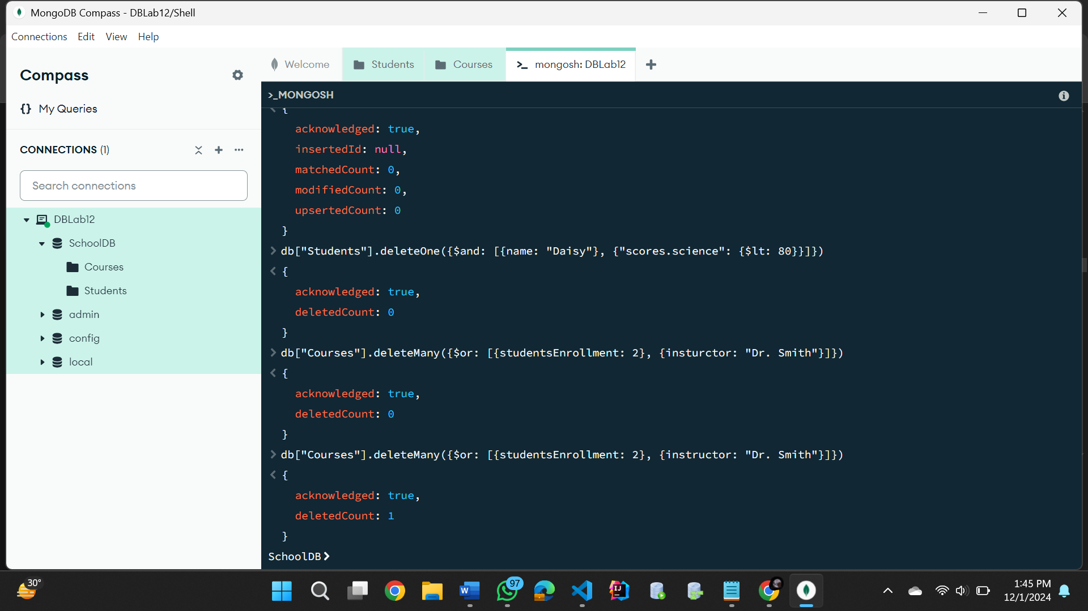

**Task no. 10**

**Task no. 11**

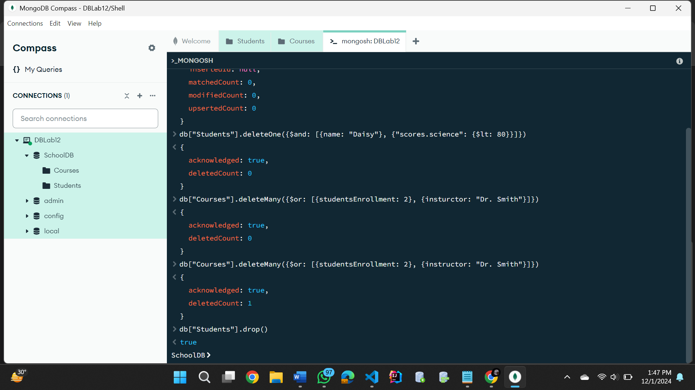

**Task no. 12**

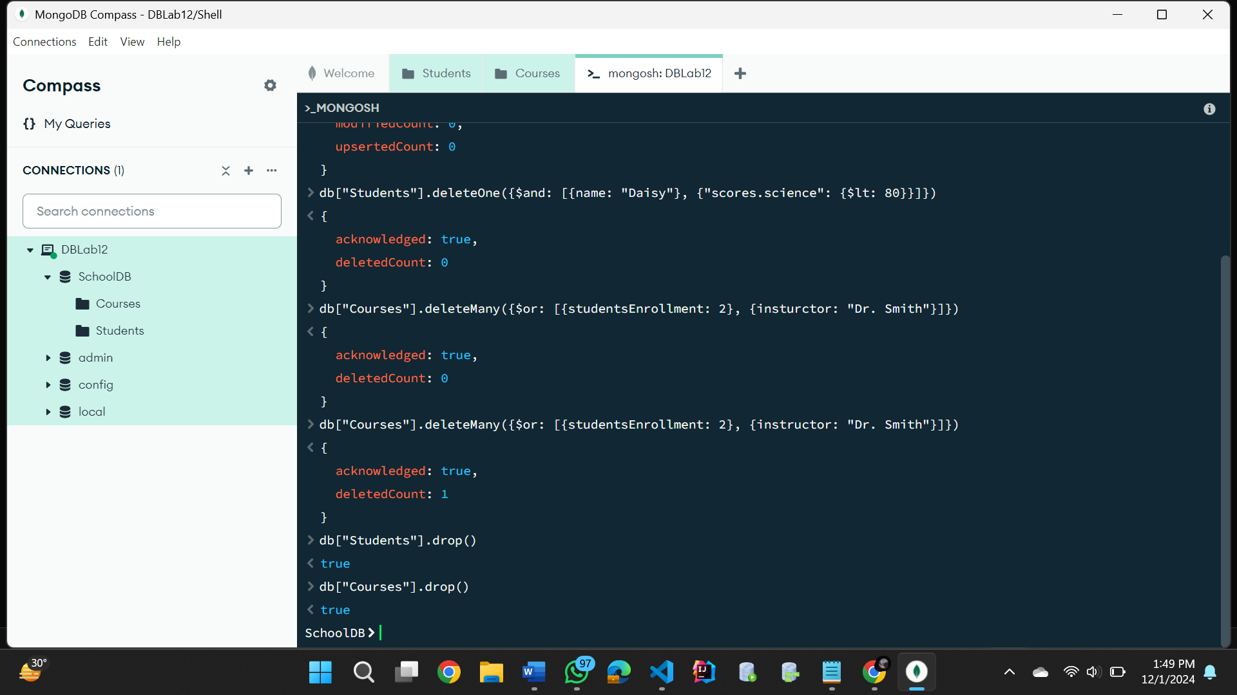

**Task no. 13**

